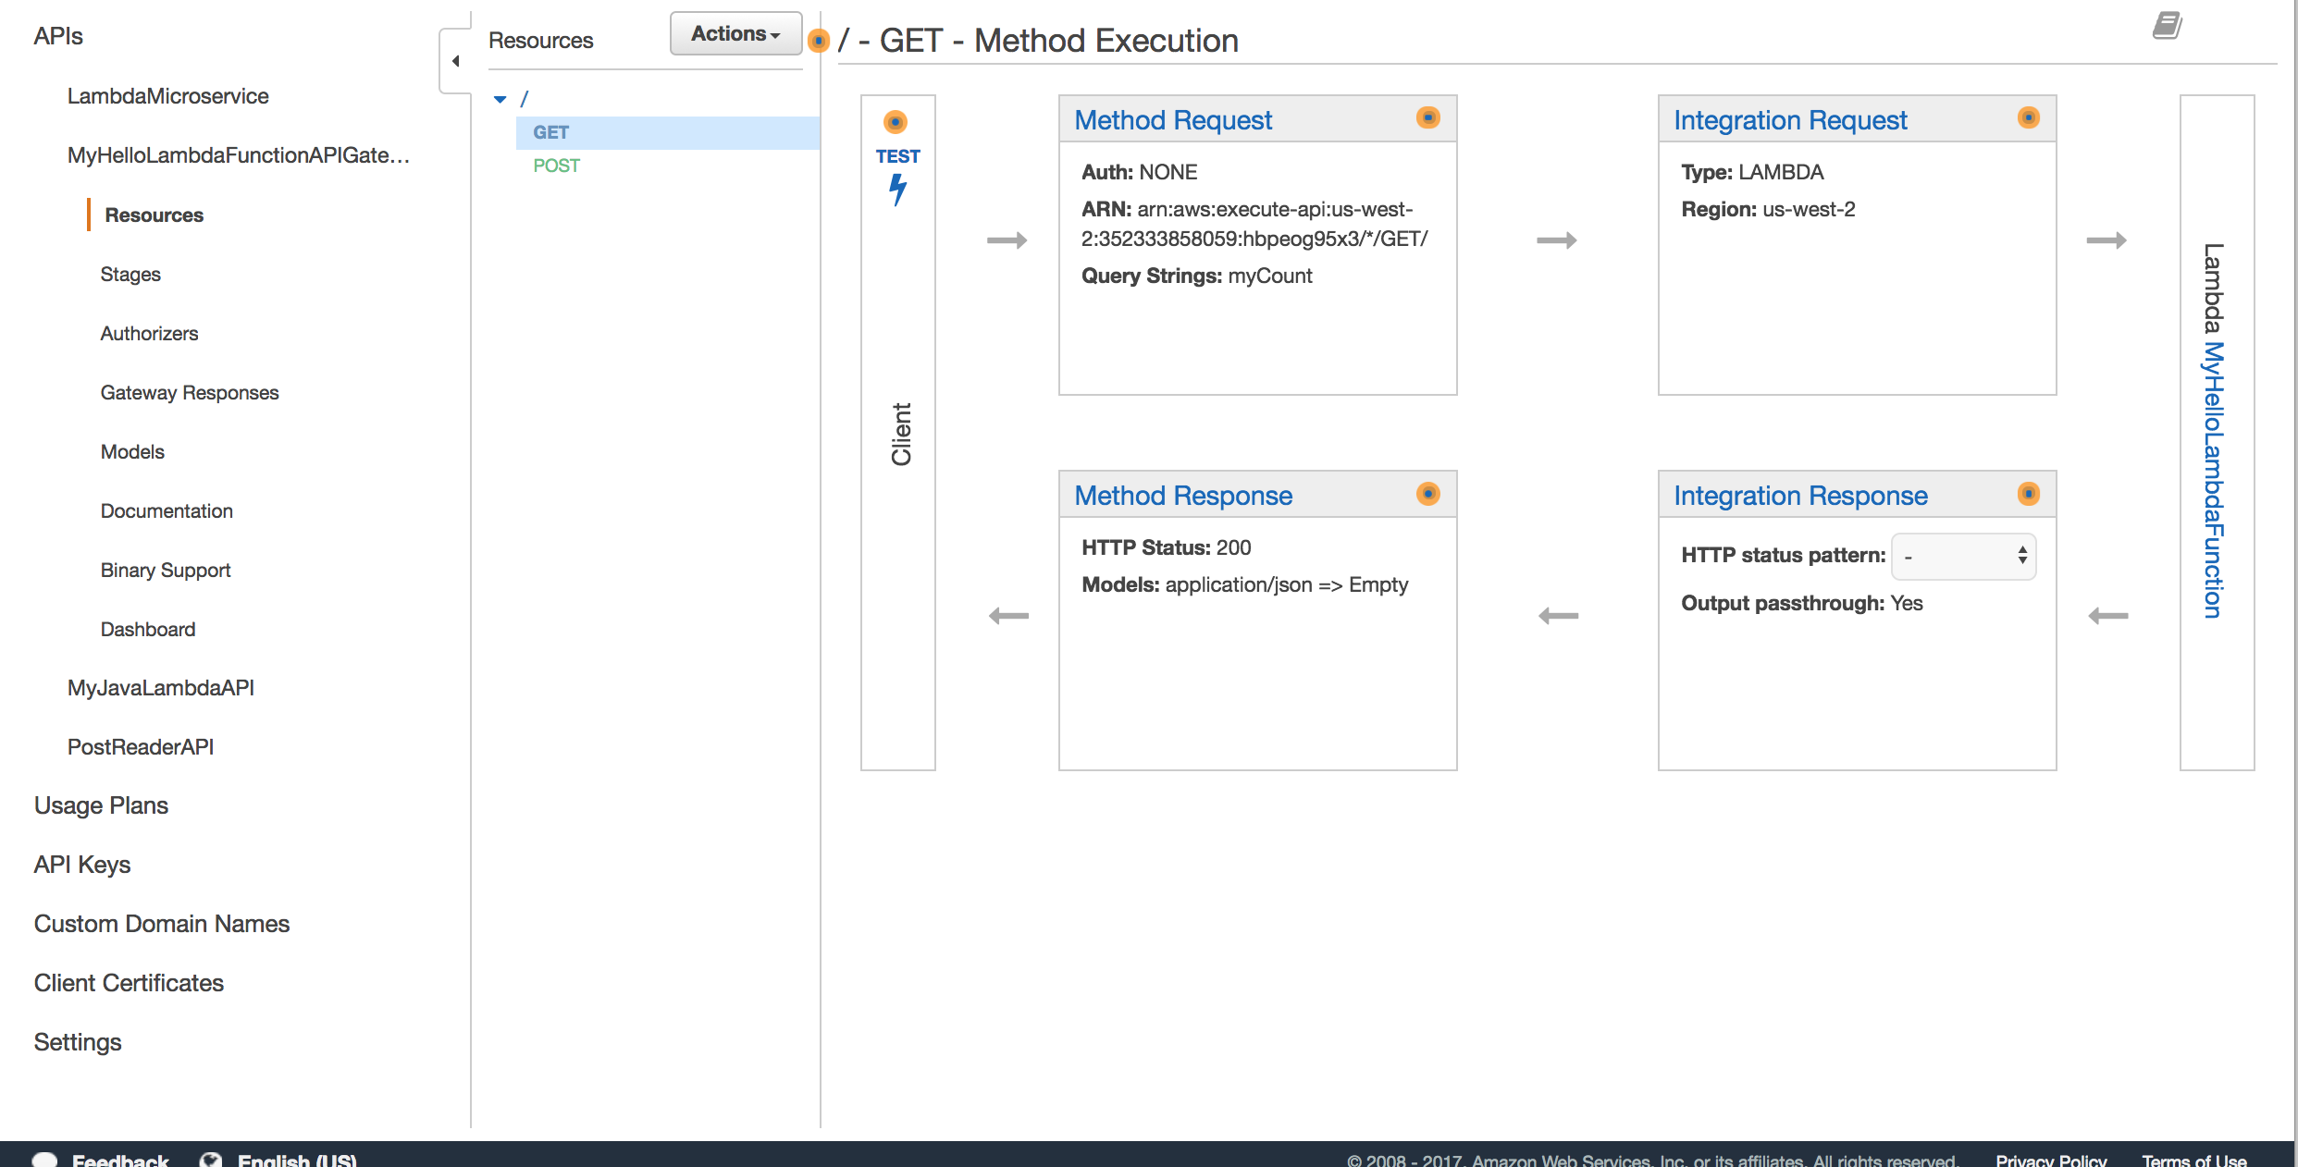

Add Query Param validation in ‘Method Request’ section.

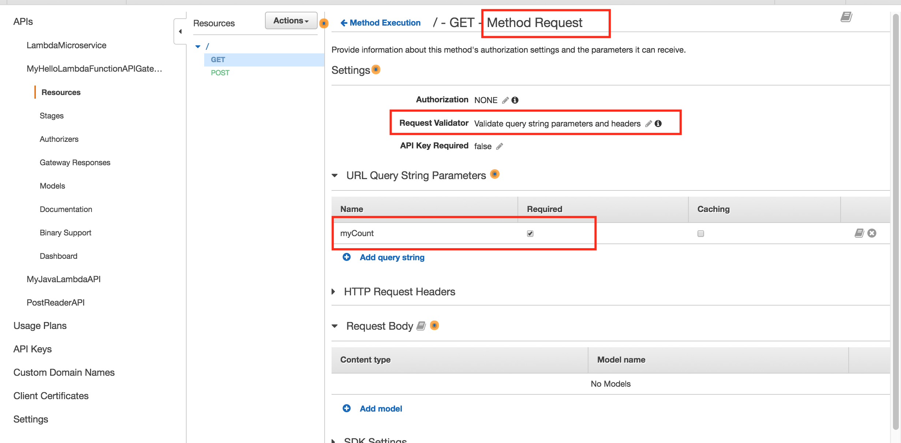

In ‘Integration Request’ section, map this query param ‘myCount’ to a json body that will be submitted a lambda function.

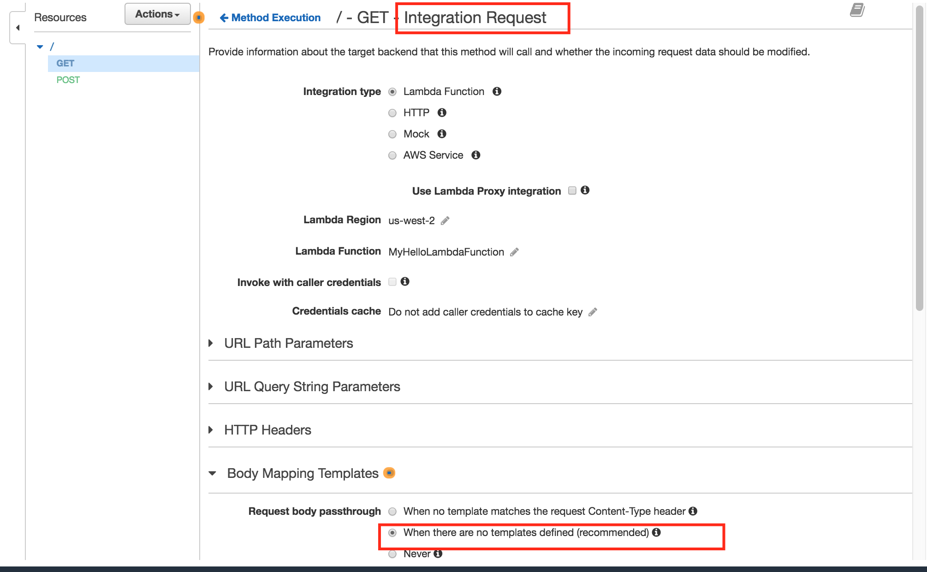

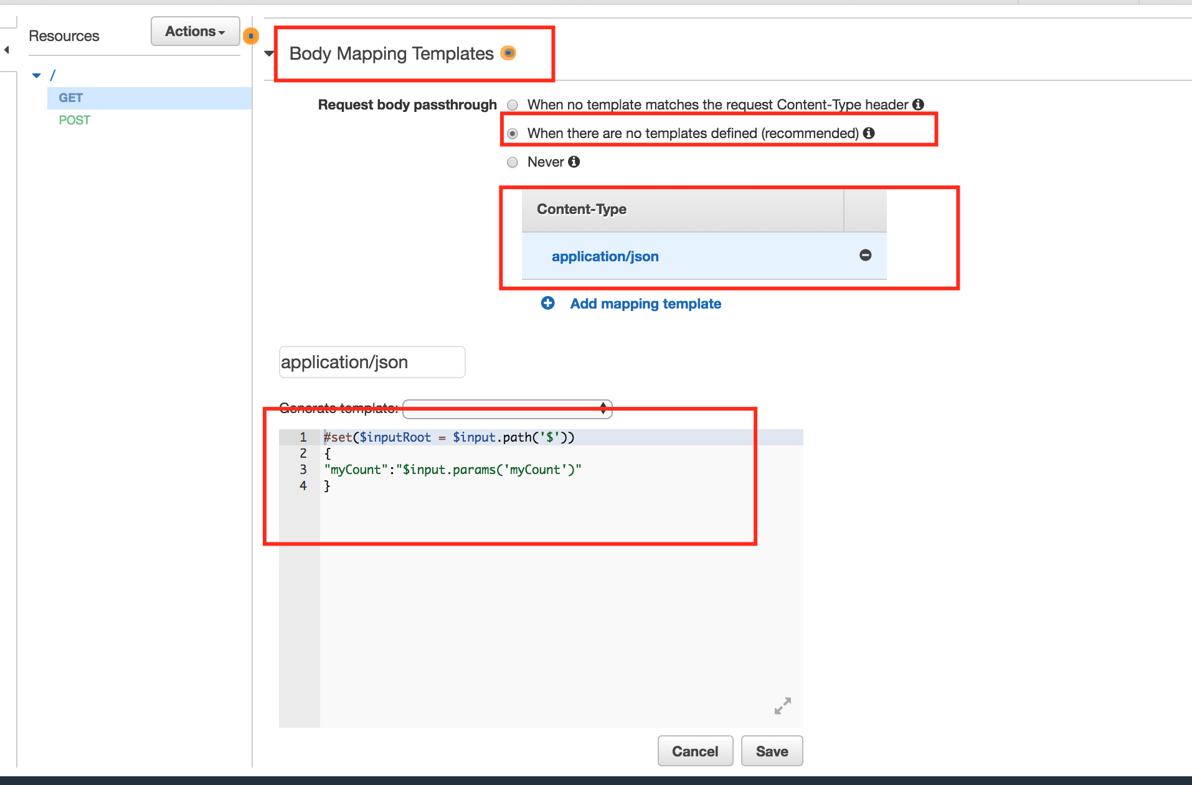

This mapping read query param ‘myCount’ and assigns it to json variable ‘myCount’.

You can have a function code as shown below. You can have a Map or java object that can be mapped to submitted Json.

public class Hello {

public String myHandlerTakingParams(**Map<String, Integer> params**, Context context) throws Exception {

if(params == null || params.size() == 0 || !params.containsKey("myCount")) throw new BadRequestException("BAD_REQ: Check your count again. It can't be <=0");

Integer myCount = params.get("myCount");

if(myCount <= 0) throw new BadRequestException("BAD_REQ: Check your count again. It can't be <=0");

LambdaLogger logger = context.getLogger();

logger.log("received : " + myCount);

return String.valueOf(myCount);

}

}